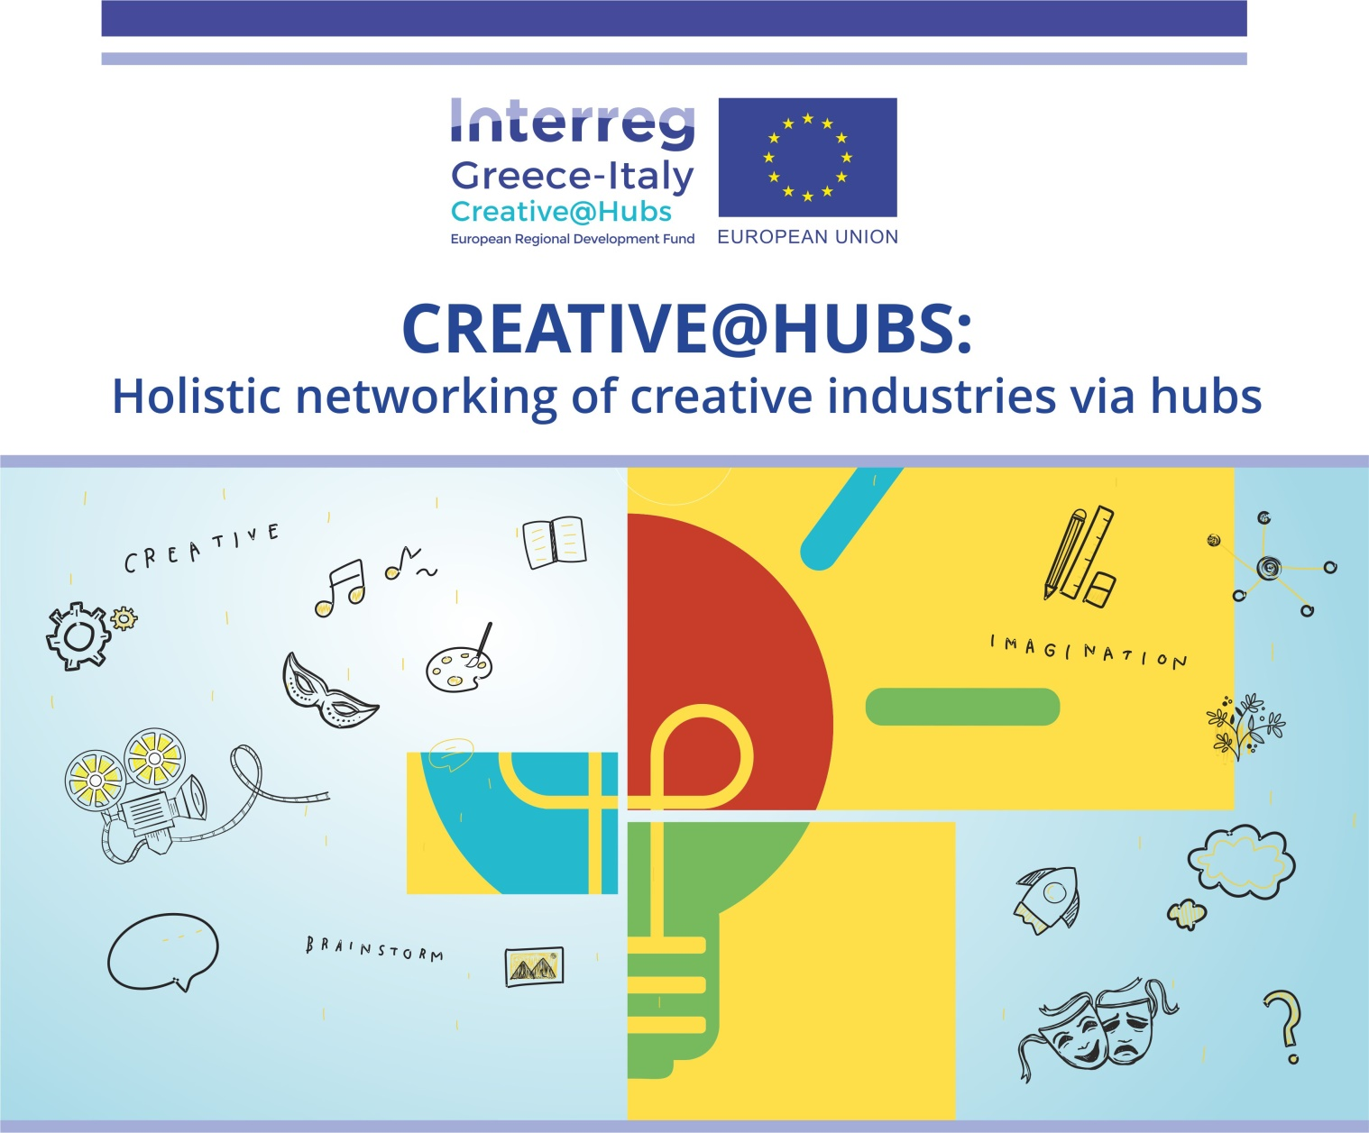
Work Package 5
Pilot activities to support exploitation and sustainability of the HUBs
Deliverable 5.1.3
Cross-Border Open Innovation Contest
November 2022

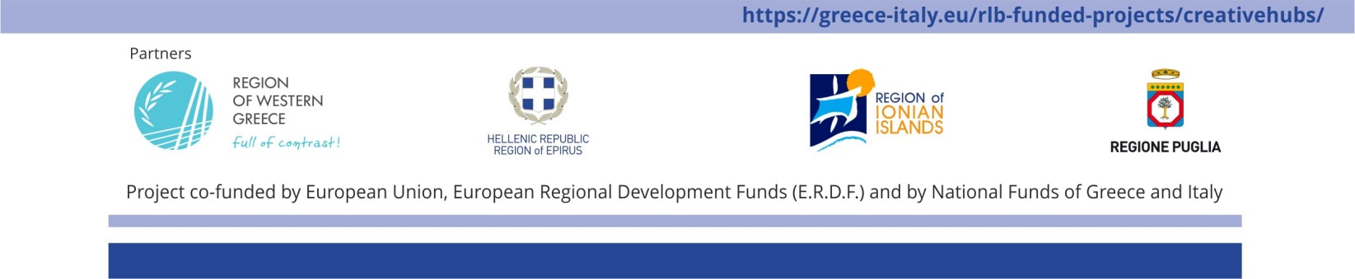
Partner responsible: Regional Development Fund - Region of Western Greece

Table of Contents
Introduction 2
Partners 4
Objectives 4
Expected Results 5
The Creative@Hubs Cross-Border Open Innovation Contest 7
A. Proposals can be submitted by: 7
B. Innovation proposals must fall into one of the following target areas: 7
C. Candidates must meet all of the following criteria: 7
D. The fields to be filled in for an innovator to participate in the idea’s contest are: 8
Awards 9
Evaluation of proposals 10
Evaluation and selection process 10
Participation terms 11
Annex A 14

Introduction
“Holistic networking of creative industries via hubs” Creative@Hubs is a Project co-funded by the European Union’s European Regional Development Fund (E.R.D.F.) and by National Funds of Greece and Italy, under the European Territorial Cooperation Programme Interreg V-A Greece-Italy 2014-2020.
Within the Regions of Western Greece, Ionian Islands, Epirus from Greece and Puglia from Italy, there are huge cultural and natural assets that can contribute to boosting their economic growth and improving people’s quality of life. Cross-border economic development has many facets: corporate partnerships, exports, or provision of services on the other side of the border, bi-location, subcontracting relationships, inter-clustering, etc.
“Cultural and Creative Industries (CCI)” are among the most dynamic sectors in the world economy, providing new opportunities for developing countries to leapfrog into emerging high growth areas of the world economy. The creative industries – which include advertising, architecture, arts and crafts, design, fashion, film, video, photography, music, performing arts, publishing, language services, research & development, software, computer games, electronic publishing, and TV/radio – are the lifeblood of the creative economy. They are also considered an important source of commercial and cultural value.
Italy’s Puglia Region has a strong potential for building a cross-sectoral laboratory to generate a creative and innovative open innovation system. The concept is for a disruptive policy-making approach, aiming at developing a “networking hub” where public policy, creative industries, food innovation clusters, rural animation clusters, universities and private companies producing best practices coexist.
New ideas are meant to be original, meaningful, and useful and capable of leading to a comparative economic advantage for the four Regions involved. Key areas of the proposed Creative Industries will be Theatres, Cinema, Street Art, Aromatic plants, Carnival and New Technologies, as well as selected actions from the thematic distribution of RIS3 in Western Greece, Tourism and culture for Epirus (with emphasis on handicrafts), Culture and creative economy for the Ionian Islands (with emphasis on music), Agriculture and food production for the valorisation and marketing of agricultural, seafood, typical and traditional local products of Puglia.
The target groups that will benefit are creative industries (start-ups, young entrepreneurships, current entrepreneurs, private companies in rural areas and a variety of SMEs in the predefined fields).

Greece and Italy have great cultural and natural assets that can help boost their economic growth and improve people's quality of life. As the overall objective of the project is to enhance the regions' capacity to create new knowledge and generate innovation through increased synergies, it goes hand in hand with the overall objective of Greece and Italy to support strategic cross-border cooperation and develop the foundations for a dynamic economy.

Partners
The project partners are:
Lead Beneficiary (LB) | Region of Western Greece – Regional Development Fund of Region of Western Greece
Project Beneficiary 2 (PB2) | Region of Epirus
Project Beneficiary 3 (PB2) | Region of Ionian Islands
Project Beneficiary 4 (PB2) | Puglia Region - Agriculture, Rural and Environmental Department

Objectives
The main objective of the proposed project is to establish an increased synergy between the creative industries and public authorities in order to promote the capability of regions to create new knowledge and generate innovation. Under the proposed project, Networking supported by innovative e-tools will act as a catalyst and accelerator of entrepreneurship in the participating Regions.
This objective is compatible with the Specific objective 1.1: Delivering innovation support services and developing clusters across borders to foster competitiveness, by:
- Encouraging collaboration through optimal partnerships between different authorities responsible for creative industries,
- Supporting the integration of creative issues at governance level
- Upgrading the attractiveness of the Regions to help creative entrepreneurs and resources in the field of innovative industries.
- Improving cooperation in selected areas with a view to promoting innovation through existing local systems (clusters, laboratories, universities, science parks, etc.)
- Enhancing entrepreneurship in developing new creative standards in related industries by small and medium sized businesses.
- Supporting SMEs in their internationalisation by pooling resources for their development

Thanks to the project, 8 buildings are being renovated as functional intervening buildings, serving as new hubs and incubators in all partner regions, equipped with administrative and logistics support, and providing full support for innovation-related cross-border cooperation structures and networks.

Expected Results
The overall project is expected to establish HUBs offering co-working spaces and access to a network of actors in the relevant fields.
More specifically, the project will provide the following results:
• Boosting innovation and creating synergies with similar players within the partnership, using innovative e-tools.
• Starting, running and networking business hubs
• Good use of the HUBs and thus of the incubators and networks established within them.
• Analysis of the key success factors and criteria for sustainability of business support institutions such as BIs in the 4 Regions.
• Connecting the creative enterprises of the area with the General Public Administration, the Chamber of Commerce, the academic - research community and productive institutions
• Enhancing the capacity of young or emerging companies to utilise innovation support services and clustering opportunities.
• A framework and the appropriate infrastructure to develop tools that provide services to businesses and all stakeholders.

As regards the program specific result indicator for SO1.1 (percentage level of capacity of businesses and innovation stakeholders to utilise the available innovation support services and clusters), the project is expected to contribute significantly based on the results presented above.

The Creative@Hubs Cross-Border Open Innovation Contest
The partners of the Creative@Hubs project call the members of its 8 Hubs (in Patras, Pyrgos, Agrinio, Messolonghi, Zakynthos, Ioannina, Bari & Foggia) to take part in the Cross-Border Open Innovation Contest, as follows:

Proposals can be submitted by:
• Individuals or groups intending to start a new business activity
• Existing businesses or organisations intending to develop new products or services

Innovation proposals must fall into one of the following target areas:
1. Agri-food sector
2. Crafts / Visual-Artistic creations / Performing Arts (Theatre, Dance, Music, etc.)
3. Cultural Tourism / Cultural heritage

Candidates must meet all of the following criteria:
- Be residents or be professionally active in the Regions covered by the Interreg Greece - Italy program, i.e., the Regions of Western Greece, Epirus, the Ionian Islands and Apulia.
- Have a professional / amateur occupation or an academic background in the field of Cultural and Creative Industries with an emphasis on the target areas as described previously.
- Have proven participation in at least one of the events of the Creative@Hubs project (seminars, workshops, infodays etc.) or have been registered in the Creative Business Portal of the project: https://creativehubs-portal.cti.gr

The fields to be filled in for an innovator to participate in the idea’s contest are:
1. Description
2. What is the major innovation of your idea?
3. What are the main challenges and barriers in implementing the idea?
4. Have you already undertaken any actions towards implementation (including distinctions/awards or funding)?
5. Which will be the impact of your idea for the local/regional society?

Interested parties are kindly requested to submit their proposals in English electronically in the special form on the website (https://www.pde-oip.gr/en) by 11/12/2022, at 23:59 h, along with all necessary supporting documents, such as:
- The applicants’ CVs
- Proof of residence or place of business
- Any document evidencing an award or distinction relevant to their proposal or other accompanying material (photos, logo, leaflet etc)

Annex A contains all procedure guidelines for the registration and submission of a participation.

Awards
For each thematic section, the 3 best ideas will be awarded based on the score received, provided they meet the minimum quality criteria (minimum score). In total, 9 business proposals will be awarded.
The awards offered include the following services:
- Organisation and implementation of a mentoring program covering at least 20 hours, aimed at further developing the proposals into a business plan that will lead to a final product
- Participation in a creative sector exhibition or other event in the program’s intervention area or the networking of the awarded group with another creative hub in the framework of the project.
- Developing publicity material for each company, including the creation of a corporate identity (logo etc.) and a short video (about 2') for presenting the idea at pitching / networking events.

In particular:
- The 1st prize in each thematic section will receive all of the above services (1, 2 & 3)
- The 2nd and 3rd prizes will receive services 1 & 2.

In addition, the Region of Western Greece will undertake the participation (travel expenses) of the awarded team with the highest absolute score in a creative sector exhibition in an area outside the program’s intervention area, subject to approval by the Program’s Administrative Authority (in the event of a tie between the absolute scores of participants in different thematic sections, a public draw will be held).

Evaluation of proposals
The following scoring criteria are proposed:
- Impact of the idea on the local market and economy (weight: 2/10)
- Realistic implementation (weight: 3/10)
- Degree of innovation / originality (weight: 3/10)
- Team Ability / Skills (Weight: 2/10)
Each criterion is rated from 1 to 5 according to the level of fulfilment (e.g., 1 not fulfilled, 5 completely fulfilled).
Minimum score for participating in an award: 5/10.

Evaluation and selection process
The evaluation will be carried out by an independent 8-member committee consisting of: 2 individuals from Italy, 1 from Epirus, 1 from the Ionian Islands and 4 from Western Greece (1 from Aetoloakarnania, 1 from Helia, 1 from Achaia and 1 representative from the Region of Western Greece), with their deputies. The Committee Chair will be the representative of the RWG, as Coordinating partner, who shall have a casting vote in the event of a tie.
The results will be announced electronically on the official project website (https://greece-italy.eu/rlb-funded-projects/creativehubs/) and the winners will also be notified by email.

Participation terms
- Participation in the Entrepreneurship Contest implies unconditional acceptance of all the terms and procedures included in the contest notice without exception.
- Participation in the contest is made by submitting a proposal in the special form on the contest website (https://www.pde-oip.gr/en).
- Submission of proposals and accompanying texts must be strictly in English. All the relevant procedures will be provided in English.
- Participants declare that they are responsible for and guarantee that the proposals they have submitted for the contest are lawful, in accordance with the contest terms, original and innovative.
- Participants bear sole and full responsibility towards the contest organiser and any third party for the proposals they submit and for the accuracy of the information they declare.
- Participants solemnly state and affirm that the proposal submitted by them was created by them, belongs to them alone and that they retain the right to use, dispose of and exploit it. They also warrant that the proposal does not infringe any intellectual or industrial property rights or other rights of any natural or legal person, or otherwise that they are the rights’ holders and/or have legally acquired all rights, such as, but not limited to, industrial property of third parties, and all legitimate licenses associated with or used to produce the proposal submitted to the contest.
- Participants assume full responsibility for any claim against the contest organisers and relieve the organisation, its employees, representatives and the members of the committees of any liability for compensation, any costs and expenses or third-party claims arising from breaches of the contest terms or third-party rights, including, for example, intellectual or industrial property rights.
- The contest committee or organiser may, at any stage of the contest, request the relevant documents for cross-checking or certifying the details of the participants in accordance with the terms of the contest notice. In the event of a false statement, the organiser bears no responsibility, while maintaining at any stage of the contest the right to cancel the participation of those who have provided false information.
- Proposals containing illegal or irrelevant material and proposals not related to any of the themes are excluded from the contest.
- Each applicant may only participate in one proposal per category. If an applicant participates in more than one proposal, all proposals will be cancelled.
- If applicants so wish, their proposals will be published on the platform after the closing date of the call for proposals.
- The following individuals may not take part in the contest: the employees of the contest organiser, the members of the contest committees, as well as the spouses and relatives of the aforementioned up to the second degree.
- The cost of preparing the proposals submitted to the contest (e.g., laboratory tests, etc.) shall be borne exclusively by the participants.
- Business ideas and plans submitted for the contest remain confidential, and copyrights and industrial property rights belong to their respective creators. Participants grant the organiser, officers and representatives and the members of the jury the right to use the submitted data and information for the purposes of the contest and for reasonable disclosure, including over the Internet.
- The contest organisers have the right to modify the contest terms or to postpone the procedure at any stage or to cancel the contest without prior notice, by posting updates at https://www.pde-oip.gr/en and at the project website https://greece-italy.eu/rlb-funded-projects/creativehubs/, without bearing any liability towards participants in the contest or towards any third party.

You can find more details about the project at: https://creativehubs.cti.gr/.

Annex A
Guidelines for Registration on the Open Innovation Platform & Participation in the Creative@Hubs Cross-Border Open Innovation Contest
- On the following link https://www.pde-oip.gr/en press, at the top and right, the “Register/Login”
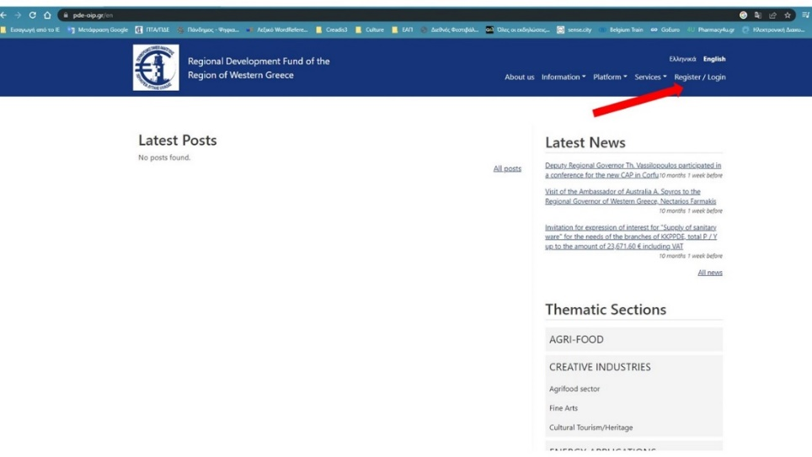
- Press the button “CREATE NEW ACCOUNT”
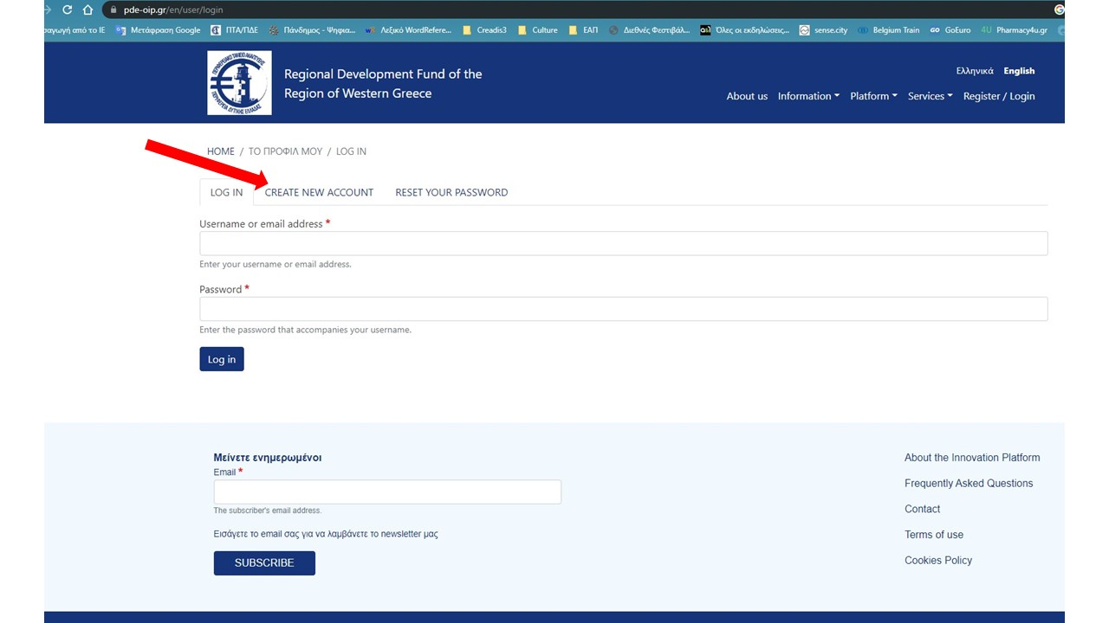
- In the environment that you will be transferred, in the "User Type" field, select "Citizen". Then, enter your details in the fields: “Name”, “Surname”, “Email address” and “Username”. All other fields are optional.
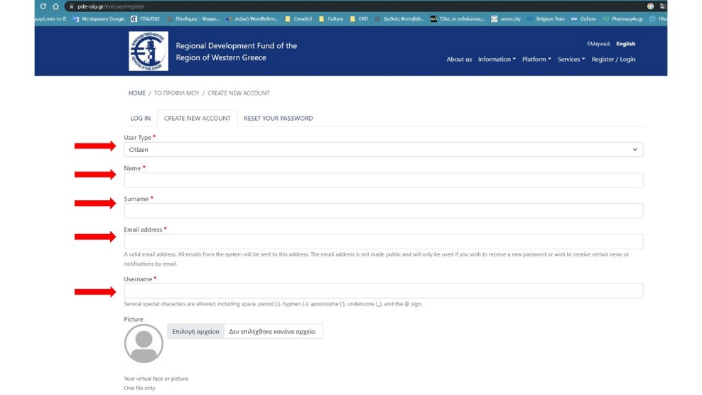
- Finally, press "Create New Account" by solving a simple math question ("math question") that will be presented to you. Repeat the click on “Create New Account”.
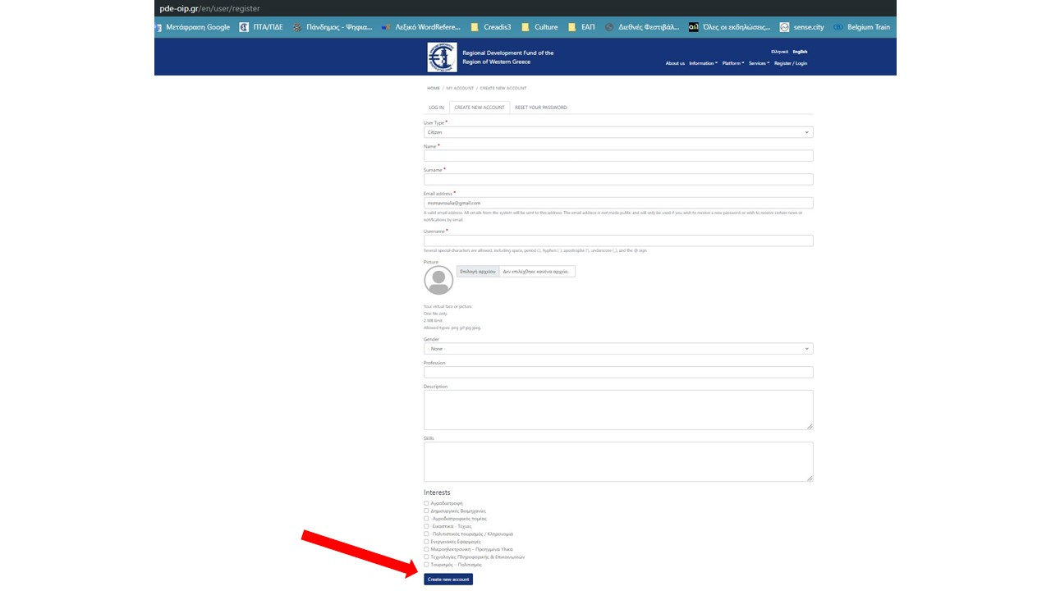
- Afterwards, you will receive an e-mail to the e-mail account you registered. Follow the instructions to complete your registration, defining your login password.
After pressing “Save”, you will be asked to solve a simple math question (“math question”). Then, press “Save” again.
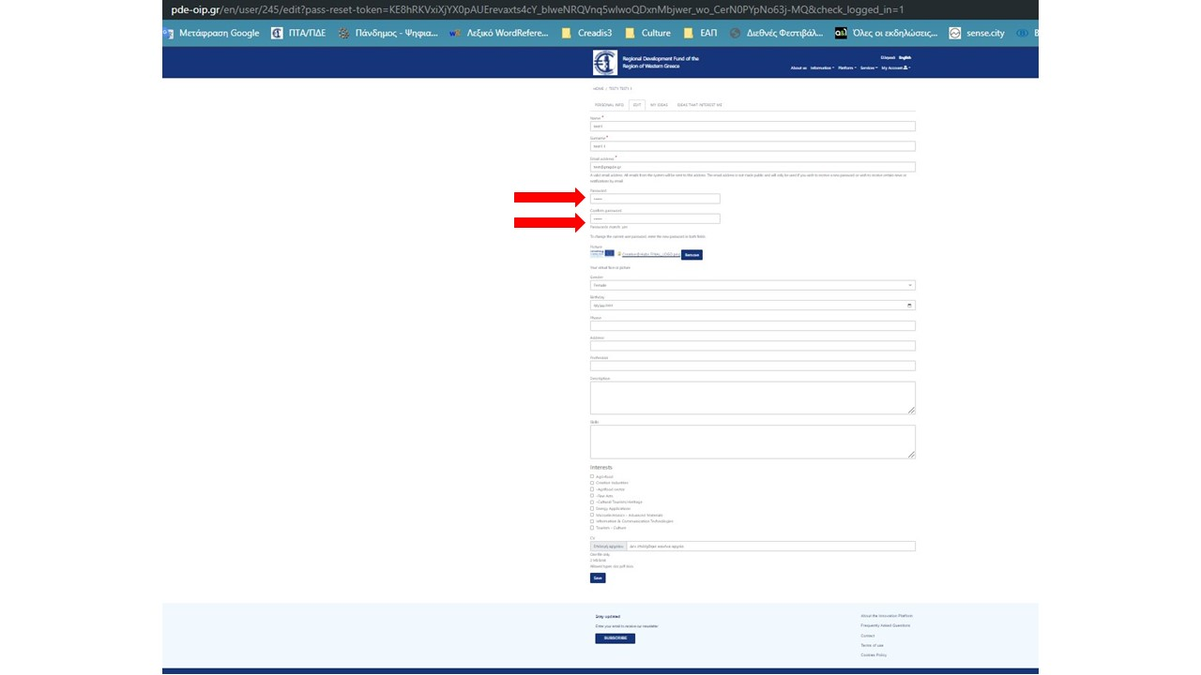

- Select “Citizens” at the top-right and under “Services”
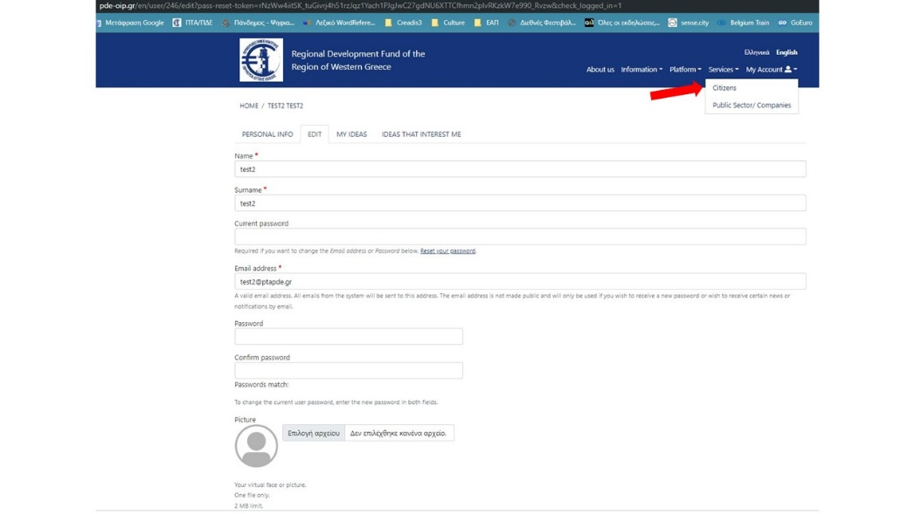
- On the right side of the screen, select “New Idea”
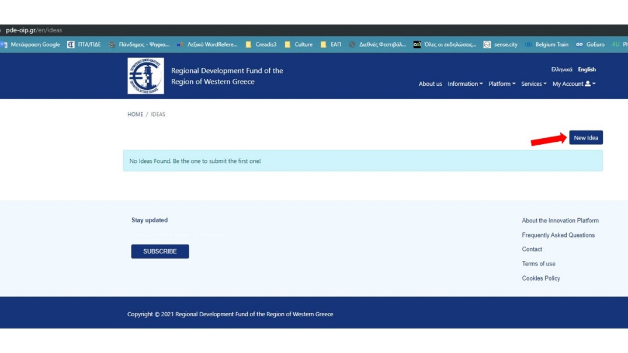

- Having been transferred to the environment for submitting your idea, fill in the requested fields, selecting in the sector (“Sector”) the thematic field of the CCIs in which you participate under the Creative Industries: Agri-food sector or Crafts / Visual-Artistic creations / Performing Arts or Cultural Tourism/Heritage.
- Enter the title of your idea.
- Describe your idea.
You will be asked to answer the following questions:
- What is the major innovation of your idea?
- What are the main challenges and barriers in implementing the idea?
- Have you already undertaken any actions towards implementation (including distinctions/awards or funding)?
- Which will be the impact of your idea for the local/regional society?

Upload your CV in the field that asks for it.
At the “Accompanied documents” field, if you wish, you can upload up to 3 files, supporting the submission of your idea.
To prove your participation in the Creative@Hubs project’s affairs, note at the "Hub Reference" field, the Hub you are involved with, as defined in the participation rights of the invitation.
To prove the condition of your place of residence or activity (in the Regions: Apulia, Western Greece, Epirus, Ionian Islands) upload in the field "Verification Document (place of residency or activity)" a file proving it.

We note that where there is a red asterisk (*), the fields are mandatory, and it is also mandatory to consent to the last 2 fields:
All the information and documents are correct
I consent to the publication of my application details on the platform after the closing date of the contest
Press "Save" and by solving a simple math question ("math question") that will be presented to you, repeat pressing "Save".
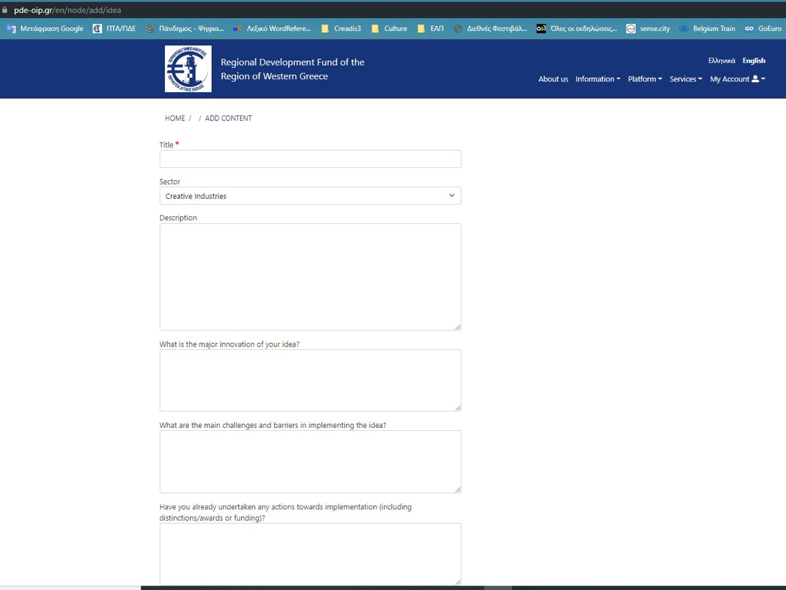
Your participation has been successfully registered.
You can now exit your account with “Log out”.
Through your account, you can see the submission of your idea, to manage your personal information, and also to follow the topics that you are interesting for.
-----------------------------------------------
In case you wish to change some data from those you submitted with your proposal, strictly and only until the end of the contest deadline, you can do it through your account by selecting "MY IDEAS" field as follows:
Next to the title of your proposal, select the icon with the pencil. Afterwards, you have the option to edit your proposal and resubmit it, as shown during step 8.

