PRESS RELEASE
The Transnational Project Creative@Hubs - Interreg V-A Greece-Italy 2014-2020 conducts an Open Innovation Contest for creators, artists, organizations and companies in the field of Cultural & Creative Industries (CCIs)
As part of the Creative@Hubs project of the European Territorial Cooperation Programme "Interreg V-A Greece-Italy 2014-2020", a Cross-Border Open Innovation Contest is being held in the following thematic areas:
- Agri-food sector
- Crafts / Visual-Artistic creations / Performing Arts (Theatre, Dance, Music, etc.)
- Cultural Tourism / cultural heritage
Proposals can be submitted by:
- Individuals or groups intending to start a new business activity
- Existing businesses or organizations that intend to develop new products or services
Candidates must meet all of the following criteria:
- Be residents or be professionally active in the Regions covered by the Interreg Greece - Italy program, i.e., the Regions of Western Greece, Epirus, Ionian Islands and Apulia.
- Have a professional / amateur occupation or an academic background in the field of Cultural and Creative Industries with an emphasis on the target areas as described previously.
- Have proven participation in at least one of the events of the Creative@Hubs project (seminars, workshops, infodays etc.) or have been registered in the Creative Business Portal of the project: https://creativehubs-portal.cti.gr.
Due to the Cross-Border nature, proposals will be submitted in the English language.
Proposals will be submitted electronically to the Open Innovation Platform of the Regional Development Fund of the Region of Western Greece (www.pde-oip.gr/en) not later than Sunday 11/12/2022,at 23:59 h.
For each thematic section, the 3 best ideas will be awarded based on the score they receive, as long as they meet the minimum quality criteria (minimum score). In total, 9 business proposals will be awarded.
The awards offered include the following services:
- The organization and implementation of a mentoring program of at least 20 hours with the aim of further developing the proposals into a business plan that will lead to a final product
- The participation in an exhibition or other event of the creative sector in the intervention area of the program or the networking of the awarded group with another creative hub in the context of the project.
- The development of publicity material for each company that includes the creation of a corporate identity (logo etc.) and the development of a short video (about 2') for the presentation of the idea in a pitching / networking event.
In particular, the first prize in each thematic section will receive all of the above services (1, 2 and 3), the second and third prizes will receive services 1 and 2.
In addition, the RWG will undertake the participation (travel expenses) of the awarded team with the highest absolute score in an exhibition of the creative sector in an area outside the intervention area of the program, subject to the approval by the Administrative Authority of the Program (in case of a tie of different thematic sections, a public lottery will be held).
Detailed information and the terms of the competition can be found at the following link: https://www.pde-oip.gr/en.
On Thursday 24/11/2022, at 4.00 PM CET, an online event will be organised to provide detailed information on the competition. To participate in the event, please register at: bit.ly/CreativeHubs_Contest.
The Creative@Hubs – Interreg V-A Greece-Italy project involves four partners: Region of Western Greece – Regional Development Fund (lead), Region of Epirus, Region of Ionian Islands and Region of Apulia.
For more information, visit the project platform: https://creativehubs.cti.gr

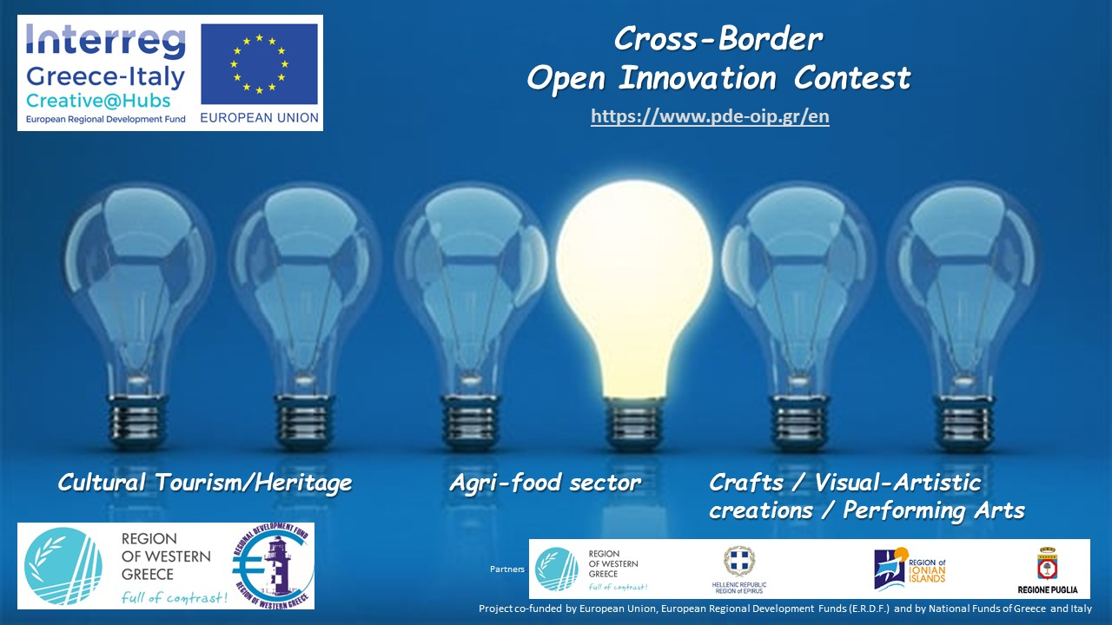

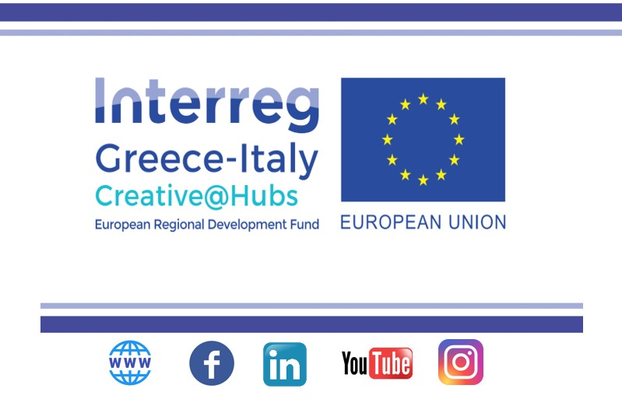

For more information, please contact the following email: (tlybereas@ptapde.gr)
Project web site: https://greece-italy.eu/rlb-funded-projects/creativehubs/
Joint Secretariat Communication Officer
Contact person: Mrs Carmela Sfregola, Tel: +39 3493916007
email: c.sfregola@greece-italy.eu
www.greece-italy.eu
Interreg V-A Greece-Italy Programme is a European Territorial Cooperation Programme that aims to help public institutions and local stakeholders to develop cross-border projects and pilot actions and to create new policy, products and services, with the final goal to improve the citizens’ quality of life.
Strategically, the programme will enhance innovation in a number of fields such as blue growth, tourism and culture, agro-food and cultural and creative industries. Interreg V-A Greece-Italy Programme aims to get maximum return from EUR 123 million financed per 85% by European Regional Development Fund (ERDF) and per 15% by the 2 member states through a national co-financing.

