HYPER / SUPER ΜΑΡΚΕΤ

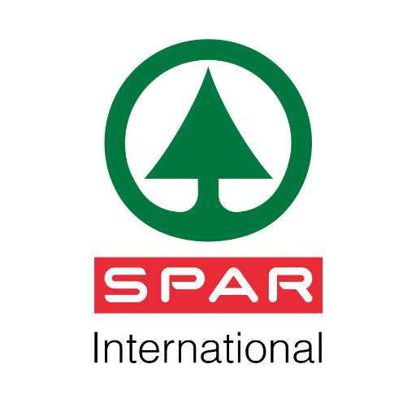  ΙΝΤΕRSPAR ALBANIA  Tirana East Gate, Lunder  Tirane, ALBANIA  Mr. Florian ZHUPA  Commercial Department - Head Division of Food Category  Tel: +355 48845912/ 044510510  Mobile: +355 696024234  E-mail: f.zhupa@spar.al; hr@spar.al  Web: www.spar.al |   CONAD SHQIPERIA SH.P.K.  Autostrada Tirane – Durres, 6th Klm. Kashar, Tirane, ALBANIA  Mobile: 00355 69 4096047  00355 69 40 960 48  E-mail: cedi.tirana@conadalbania.al  Γενικός Δ/ντής Mr. Pietro Tafuni www.conadalbania.al  ‎
  BIG MARKET  Rr. Myslym Shyri, Tirane, ALBANIA  Mr. Ilir Saliaj, Administrator  Μobile: 00355 69 40 33 777  Email: info@bigalbgroup.com;  vendite@bigalbgroup.com;  import@bigalbgroup.com;  http://bigmarket.al |   ECO MARKET FOOD SHPK  Autostrada Tiranë - Durrës Km. 7  Tirana, ALBANIA  Mr. Ilir Azizolli, Manager  00355 68 60 89 000  Tel.: 00355 4 4504286  Email: info@ecomarket-al.com;  info@ecomarket-al.com;  emance@ecomarket-al.com;  www.ecomarket-al.com

