INVITATION
The Chamber of Aetoloakarnania invites you
to attend the session being implemented
within the framework of the 3rd Agri-Food Conference & Exhibition AGROWN 2025,
on the topic:
"ECOBASE: Ecological solutions based on nature to mitigate soil degradation, supporting a greener and climate-resilient Adriatic-Ionian Macroregion”
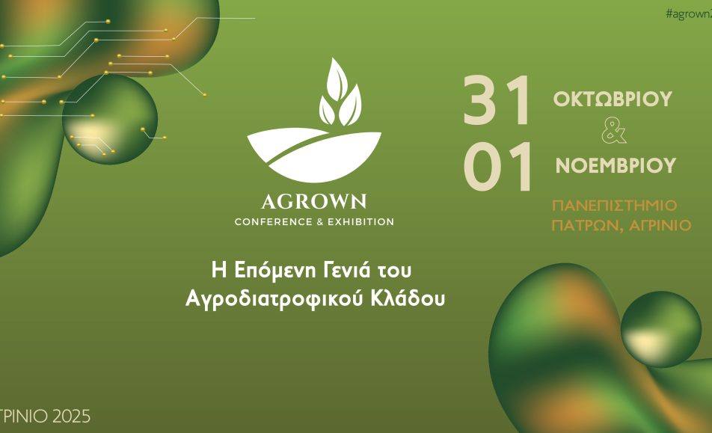
🗓 Friday, October 31, 2025
🕛 2nd Session: 11:35 – 12:05
🏛 University of Patras – Amphitheater, Agrinio

