# **INVITATION**

The **Chamber of Aetoloakarnania** invites you

to attend the session being implemented

within the framework of the **3rd Agri-Food Conference & Exhibition AGROWN 2025,**

on the topic:

**"ECOBASE: Ecological solutions based on nature to mitigate soil degradation, supporting a greener and climate-resilient Adriatic-Ionian Macroregion”**

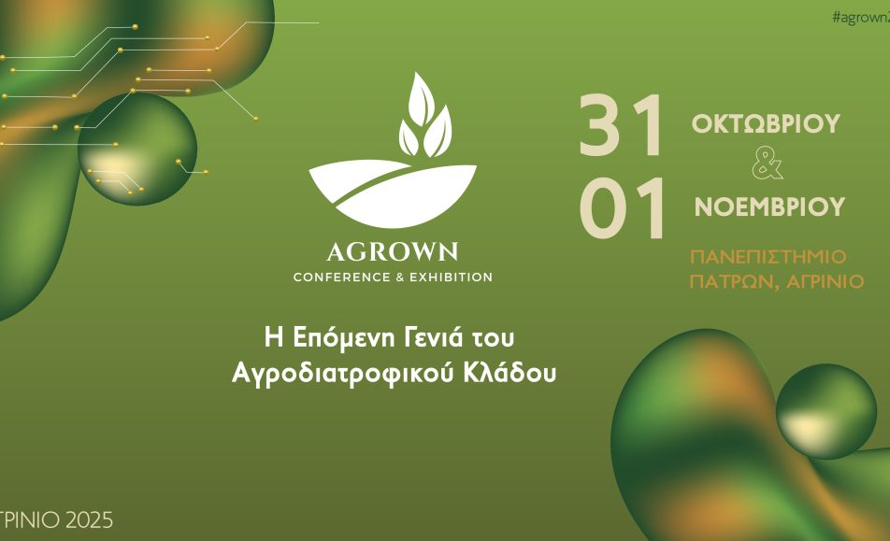

🗓 Friday, October 31, 2025

🕛 2nd Session: 11:50 – 12:20

🏛 University of Patras – Amphitheater, Agrinio