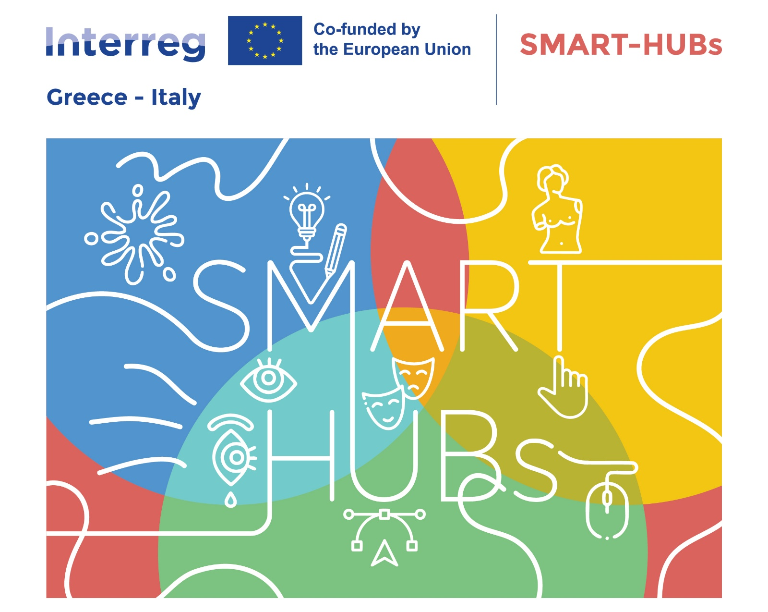
PRESS RELEASE
The SMART-HUBs Opening Conference was successfully completed in Patras
With great success and the participation of numerous stakeholders, the Opening Conference of the European project SMART-HUBs took place on Wednesday, September 24, 2025, at the Amphitheatre of the Archaeological Museum of Patras.

Opening Remarks
The event was honoured by greetings from:
- Mr. Charalambos Bonanos, Deputy Regional Governor of Western Greece, who referred to the importance of cross-border cooperation and innovation for local development, highlighting that Western Greece can become a hub of cultural creativity and youth entrepreneurship.
- Mr. Dimitris Karagiannis, representative of the Chamber of Achaia, who emphasized the importance of linking the creative economy with entrepreneurship and new markets, underlining the Chamber’s support for such initiatives.

Presentations and Interventions
During the Conference, the following presentations were delivered:
- The SMART-HUBs project: goals and objectives by Mr. Christos Tzomakas, Director of the Regional Development Fund of the Region of Western Greece (RDF-RWG).
- The Creative@Hubs project contribution by Ms. Marisofi Mavroulia, (RDF-RWG).
Scientific and professional interventions followed, focusing on creative economy, digital transformation, cultural heritage, and tourism, with contributions from:
- Mr. Andreas Tsiliras, Cultural Manager MSc, Co-founder of Mosaic // Culture & Creativity, with Creative Economy: Between Dynamics and Obstacles
- Mr. Aris Mamasioulas, Special Management Service of OP Western Greece, Unit A’, with Entrepreneurship support actions from the Regional Operational Programme "Western Greece 2021-2027"
- Dr. Konstantina Askouni, Museologist – PhD in Museum Education, Former Deputy Mayor of Finance, Culture and Social Policy, Municipality of Western Achaia, with Digital Society and Cultural Heritage: Skills, Educational Programs and New Challenges in Culture
In addition, partners from Greece and Italy presented good practices and European projects, including:
- EMOUNDERGROUNDS case study: Emotional exhibits for experiential tourism and a new transnational CCIs cluster, presented by Ms. Ida Carolla (representative of Municipality of Nardò),
- Building SMART-HUBs: Transversal and Digital Competences for innovating CCIs and tourism economy in the Euro-Mediterranean region, presented by Ms. Tiziana Carlino (representative of Materahub Cultural and Creative Industries Consortium Scarl),
- CB4E-Exhibits case study: Capacity building for the development of emotional technological exhibits to support CCIs, presented by Ms. Denise Greco (representative of Municipality of Maida).
The keynote speech was delivered by Ms. Xenia Kaldara, Chairwoman of the Board and General Director of the Michael Cacoyannis Foundation, on the topic: “Digital Skills Development in Cultural and Creative Industries.”
In the afternoon, the conference continued with presentations of research and technological applications in the fields of culture and tourism, featuring projects such as:
HERIT ADAPT Pilot: Photogrammetry of the Temple of Epikourios Apollon presented by Christos Anagnostopoulos, Industrial Systems Institute,
SPARC, a sparc that never goes out presented by Vassilis Papaioannou, Department of Digital Systems Design and Studies, Municipality of Patras,
The "CHERRY" project and its contribution to the field of CCI - The role of RWG as a project partner presented by Sofia Karveli, Head of the Department of Regional Policy Planning, Programming, Innovation & Project Evaluation of Region of Western Greece,
as well as contributions on Smart Tourism Destinations and Digital Transformation in Culture, presented by Alkiviadis Panagopoulos, Professor, Director, Laboratory of Information Systems and Forecasting in Tourism, Department of Tourism Management, University of Patras.
The event concluded with an open discussion, Q&A session, and exchange of views among participants, confirming the crucial role of the creative and cultural industries in local and regional development.
After the lunch break, participants also had the opportunity to visit the Archaeological Museum of Patras and the art exhibition “Alive Heritage: Matter and Memory – Greek Diaspora Artists.”
The SMART-HUBs project aspires to create a dynamic ecosystem that will foster sustainable regional development, offer new opportunities for young people, and strengthen cooperation between institutions in Greece and Italy.

