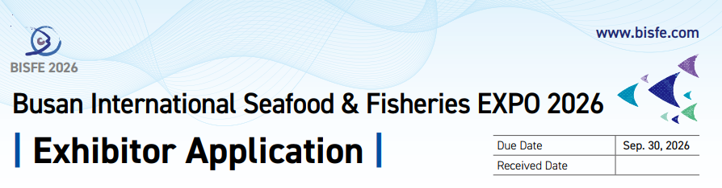1. Exhibitor Information
Company Name
Representative
Address
Products or Services to be displayed
Contact Person |  | Job Title
Telephone/Mobile |  | FAX
E-mail |  | Website
2. Participation Fee (1booth = 3m X 3m)
 |  |  | Unit Price | Requirements | Subtotal
Raw Space(Space Only) |  |  | USD 1,800/booth (9㎡) | ( )booth(s) | USD ( )  ▶Minimum 18㎡ are required to apply
Shell Scheme |  |  | USD 2,300/booth (9㎡) | ( )booth(s) | USD ( )
Premium Booth |  |  | USD 2,700/booth (9㎡) | ( )booth(s) | USD ( )
Electricity | Daytime  (10:00~  17:00) | Single Phase 220V (60Hz) | USD 70/KW | ( )kw | USD ( )
Electricity | Daytime  (10:00~  17:00) | Three Phase 220V(60Hz) | USD 70/KW | ( ) kw | USD ( )
Electricity | Daytime  (10:00~  17:00) | Three Phase 380V (60Hz) | USD 70/KW | ( ) kw | USD ( )
Electricity | 24hours | Single Phase 220V (60Hz) | USD 90/KW | ( ) kw | USD ( )  ▶Mandatory for freezer/refrigerator users
Electricity | 24hours | Three Phase 220V(60Hz) | USD 90/KW | ( ) kw | USD ( )  ▶Mandatory for freezer/refrigerator users
Electricity | 24hours | Three Phase 380V (60Hz) | USD 90/KW | ( ) kw | USD ( )  ▶Mandatory for freezer/refrigerator users
Water & Drain |  |  | USD 200 | ( ) ea | USD ( )
Compressed Air |  |  | USD 200 | ( ) ea | USD ( )
LAN Cable |  |  | USD 150 | ( ) port | USD ( )
Visitor Reception System |  |  | USD 180 | ( ) ea | USD ( )
TOTAL |  |  |  |  | USD ( )
3. Payment
Deadline | September 30, 2026 (First Come First Served)
Bank Name | Busan Bank | Account No. | 320-01-000477-1
Beneficiary | BEXCO | Swift Code | PUSBKR2PXXX
- Please ensure that your company name is stated on your payment
- Payment Procedure
- First half payment: 50% of the participation fee within 2 weeks once you submit the application form.
- Second half payment: Remaining 50% due by Sep. 30, 2026.
We hereby apply for participation in BISFE 2026 as stated above, and we fully acknowledge and accept all the terms and conditions on the following page.
2026 Representative: Signature:
BEXCO, BISFE SECRETARIAT 55, APEC-ro, Haeundae-gu, Busan, Republic of Korea (ZIP 48060)
TEL : +82-51-740-7518, 7519 FAX: +82-51-740-7640 / E-mail: bisfe@bexco.co.kr / bisfekorea@gmail.com
